Fort Larned Scavenger Hunt
This activity includes 25 information cards and a student response sheet. The basic idea is that the 25 cards are placed around the room for students to find. They could be hidden or just simply placed around the room for students to find. They do not need to be put in the number order. Students then walk around the room and find the cards. They can do this individually or with a partner. They will find the card, read the facts on the card, and answer the corresponding question on their student response sheet.

Student Response Sheet

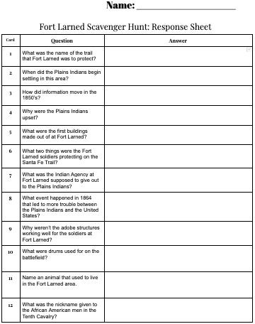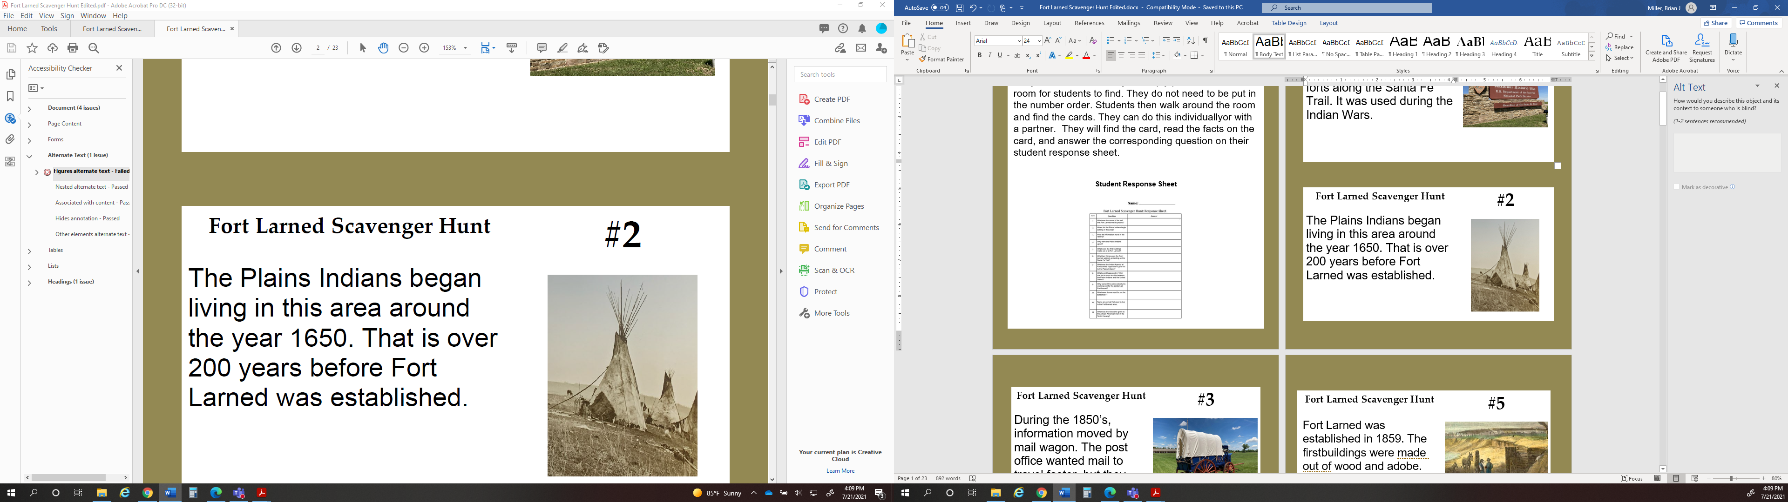
Scavenger Hunt Card

Fort Larned Scavenger Hunt | #1
Fort Larned is known as one of the best-preserved forts along the Santa Fe Trail. It was used during the Indian Wars. | 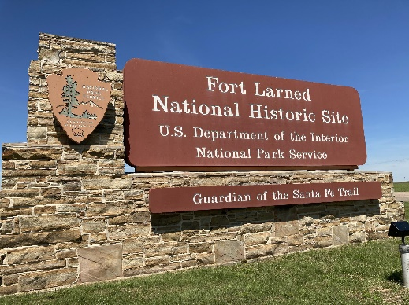

Fort Larned Scavenger Hunt | #2
The Plains Indians began living in this area around the year 1650. That is over 200 years before Fort Larned was established. | 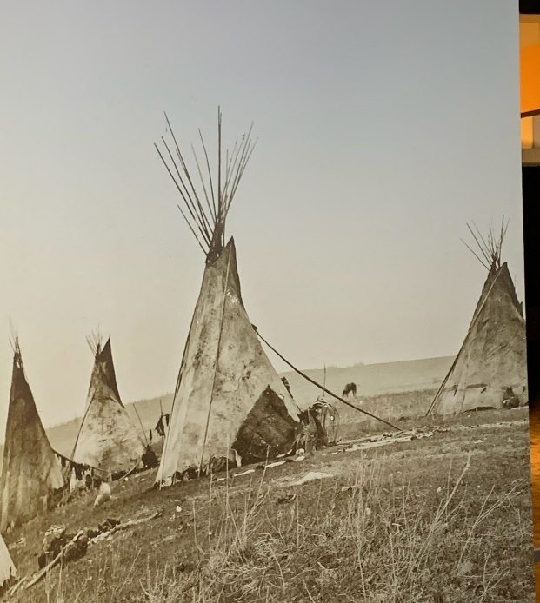

Fort Larned Scavenger Hunt | #3
During the 1850’s, information moved by mail wagon. The post office wanted mail to travel faster, but they needed protection from the Plains Indians. | 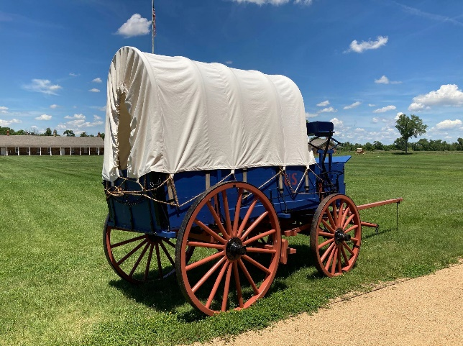

Fort Larned Scavenger Hunt | #4
Wagons and traders on the Santa Fe Trail continued to push the Plains Indians further away from their homes and their main food source- the buffalo. This caused lots of problems. | 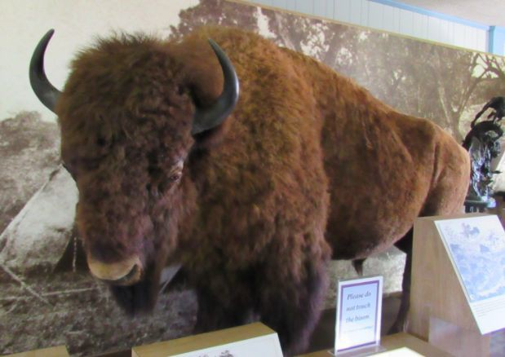

Fort Larned Scavenger Hunt | #5
Fort Larned was established in 1859. The first buildings were made out of wood and adobe. | 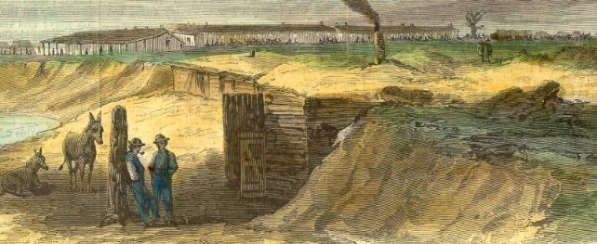

Fort Larned Scavenger Hunt | #6
The soldiers at Fort Larned were there to protect the mail service and travelers on the Santa Fe Trail. | 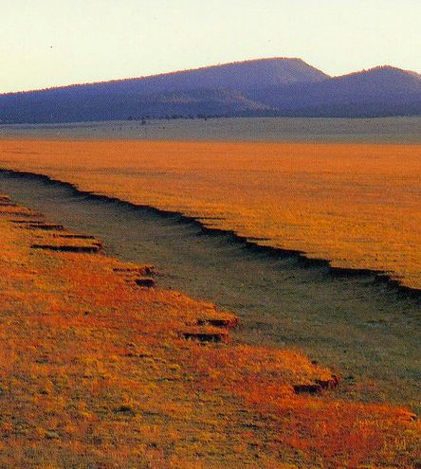

Fort Larned Scavenger Hunt | #7
In 1862, the government set up an Indian Agency at Fort Larned. This was supposed to be a way for the Plains Indians to receive supplies that were promised to them in treaties. However, the everyday life of a Plains Indian was greatly disrupted. | 

Fort Larned Scavenger Hunt | #8
There were many conflicts with the United States and the Plains Indians. One of the worst was called the Sand Creek Massacre.  In 1864, Colonel John Chivington led an attack that killed 230 men, women, and children. This has been described as an unfair and cowardly attack. | 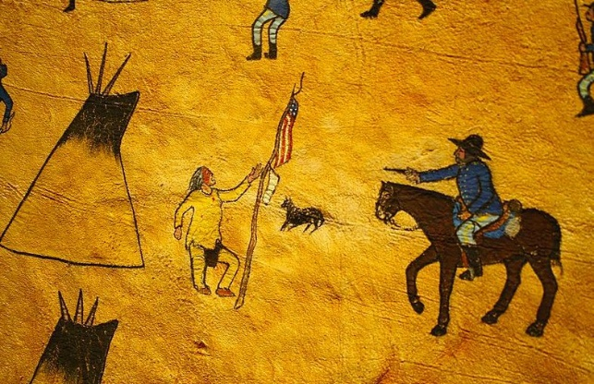
Fort Larned Scavenger Hunt | #9
By 1865, the adobe  structures at Fort Larned were falling apart. Soldiers felt threatened by possible Indian attacks. Construction on the sandstone buildings began the next year. | 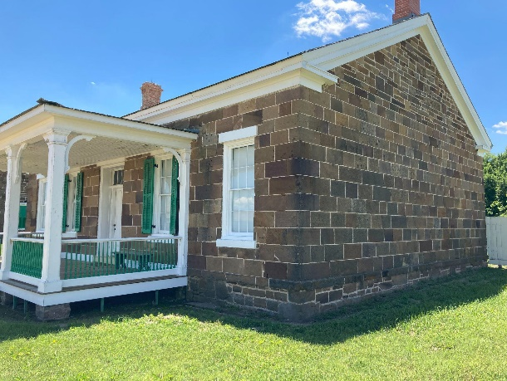

Fort Larned Scavenger Hunt | #10
Music was common at the fort. This helped soldiers relax and have fun with each other. They also used drums and bugles to give orders on the battlefield. | 

Fort Larned Scavenger Hunt | #11
Fort Larned was built on a prairie. This open grassland was home to many different kinds of animals, including bison, wolves, and bears. | 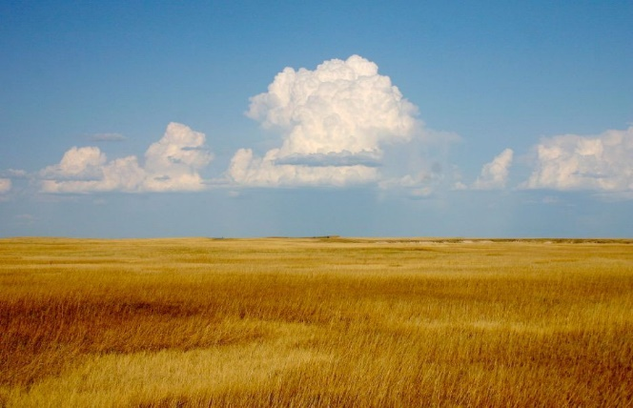

Fort Larned Scavenger Hunt | #12
The Tenth Cavalry’s African American enlisted men arrived at Fort Larned in 1867. They were nicknamed, “The Buffalo Soldiers.” | 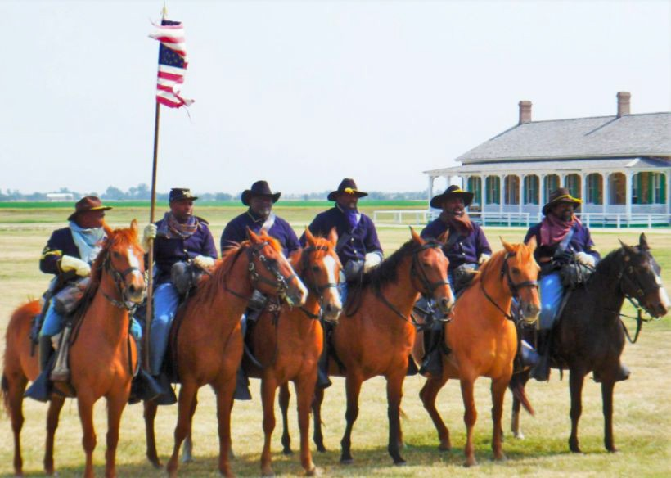

Fort Larned Scavenger Hunt | #13
Hispanic traders commonly traveled the Santa Fe Trail. After the decline of the trail, many continued to live and work near Fort Larned, bringing important contributions to the area including language, food, and culture. | 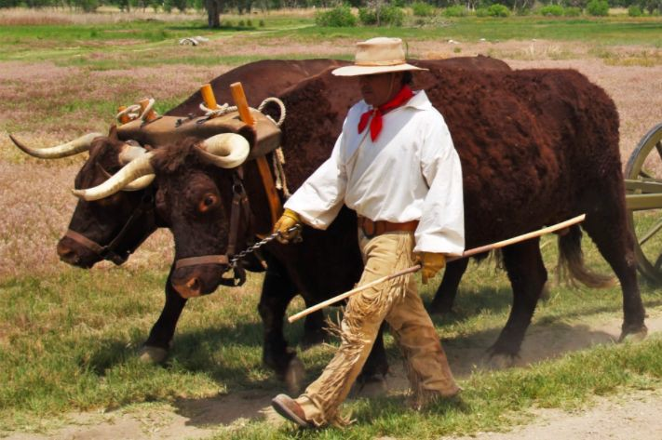

Fort Larned Scavenger Hunt | #14
German, French, Swedish, and Irish immigrants were all soldiers at Fort Larned.  Many cultures mixed here. | 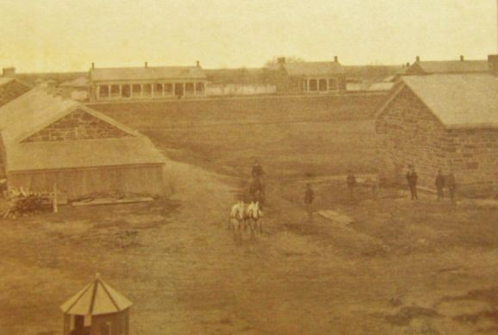

Fort Larned Scavenger Hunt | #15
A huge American flag flies atop a 100 foot pole at Fort Larned. This would have been an exciting view for a traveler along the trail. | 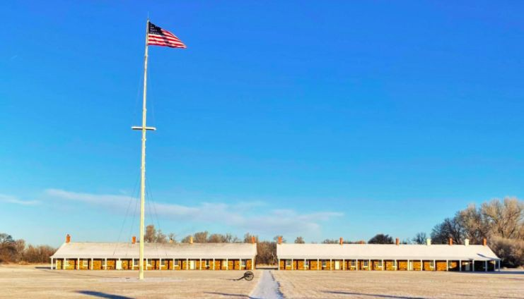

Fort Larned Scavenger Hunt | #16
Soldiers at Fort Larned were more likely to die from disease and illness than from fighting. | 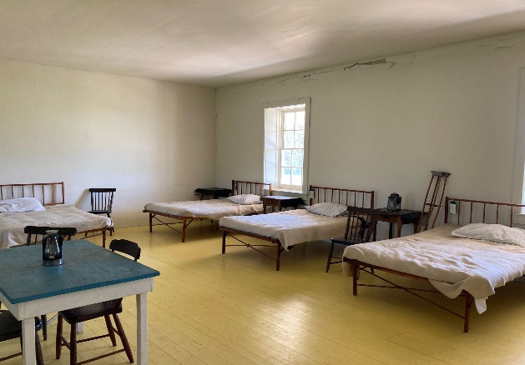

Fort Larned Scavenger Hunt | #17
The buildings at Fort Larned are made from sandstone.  This material has lasted for many years allowing us to see the fort as it looked back in the 1860’s. | 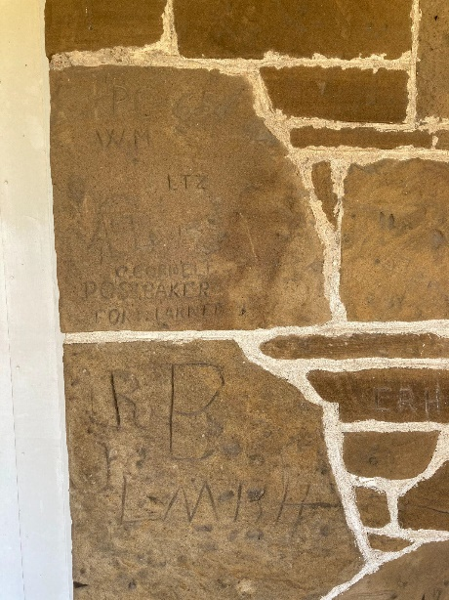

Fort Larned Scavenger Hunt | #18
You might think of a fort as having a big wall for protection. However, the Plains Indians were more likely to attack a small group of wagons than carry out a large fight. So a wall around Fort Larned was not needed. | 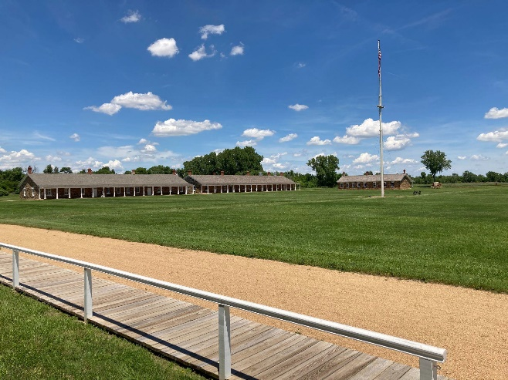

Fort Larned Scavenger Hunt | #19
Women could work at the fort as laundresses.  They made about $40 a month, more than double what a soldier made. | 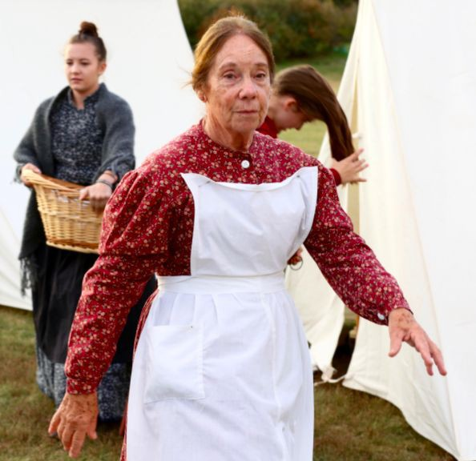

Fort Larned Scavenger Hunt | #20
Over time, the wagons traveling the Santa Fe Trail cut deep ruts into the ground. You can still see these ruts today just a few miles from the fort. | 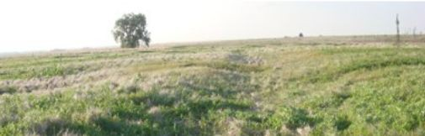

Fort Larned Scavenger Hunt | #21
The soldiers at Fort Larned were given the job of escorting the mail. This was usually a group of 10-20 men. | 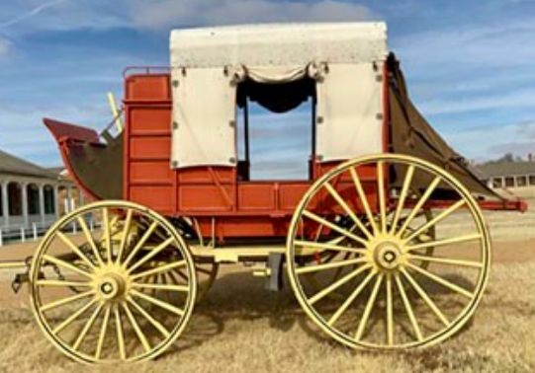

Fort Larned Scavenger Hunt | #22
By 1872, there were very few wagons on the Santa Fe Trail due the new railroads. | 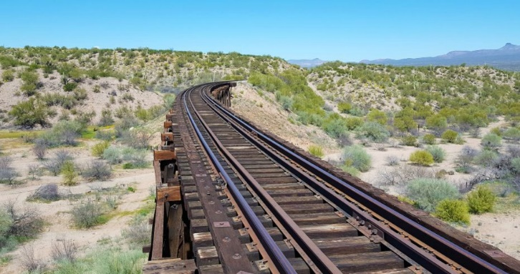

Fort Larned Scavenger Hunt | #23
If you look at a map of the original Fort Larned, you will see other buildings as well. These were not constructed out of durable sandstone, and they are no longer here today. | 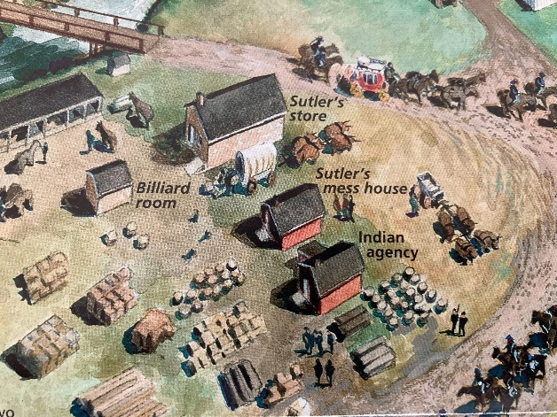

Fort Larned Scavenger Hunt | #24
In 1884, the fort was made into a private ranch. You will notice carvings on the buildings at Fort Larned. Most of these carvings happened during this time. | 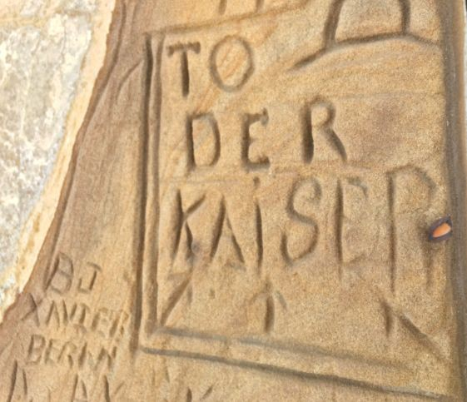
Fort Larned Scavenger Hunt | #25
In 1964, President Lyndon Johnson established Fort Larned as a National Historic Site. This allowed the fort to become what it is today, as a site for us to enjoy and learn from. | 